Lab Assignment 6

Name: Udaya Byreddy ID: 16293204 Class ID: 3 Lab ID: 6\_2

The agenda of this assignment is to perform CRUD operations on the customer notes. Add, update, delete and read the customerID, customerName, customerEmail.

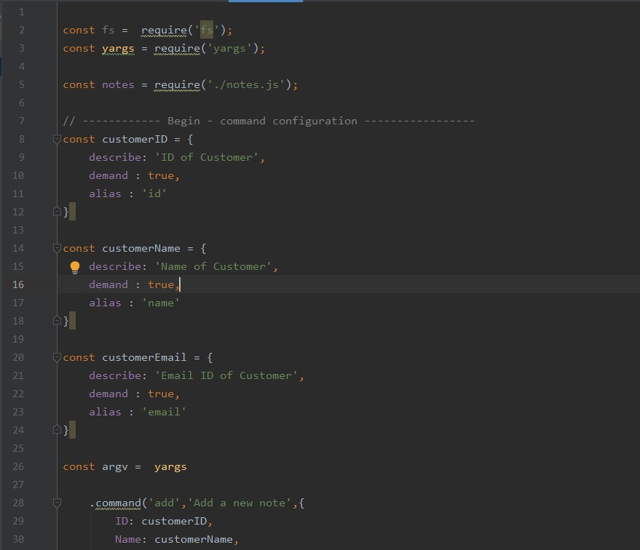

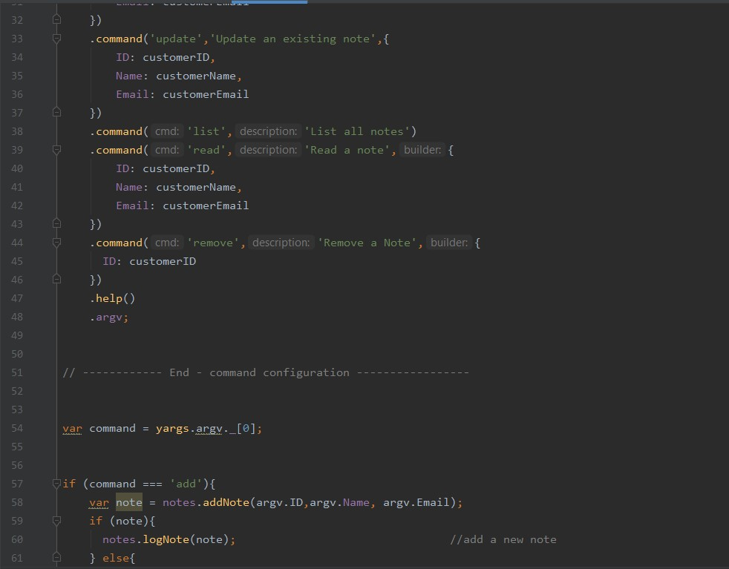

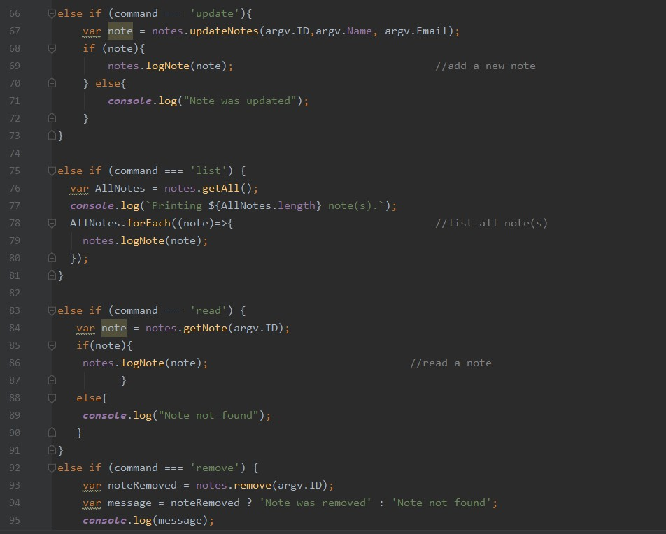

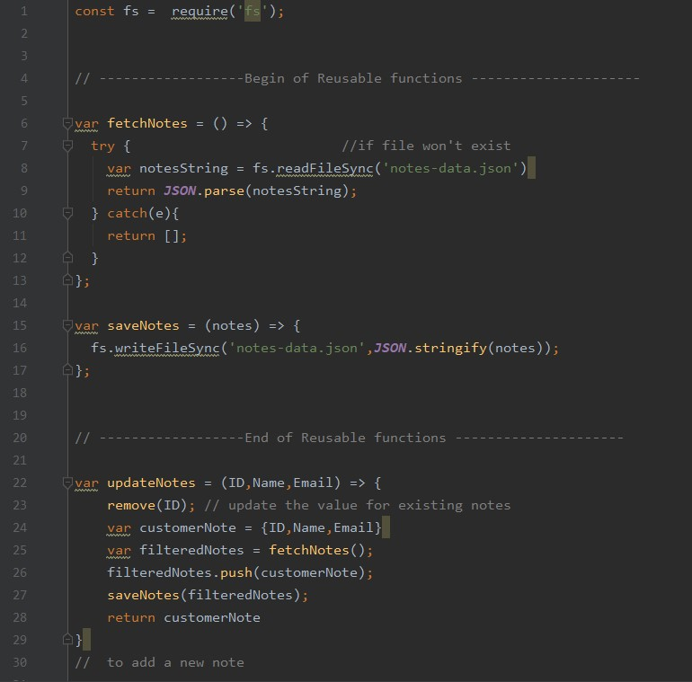

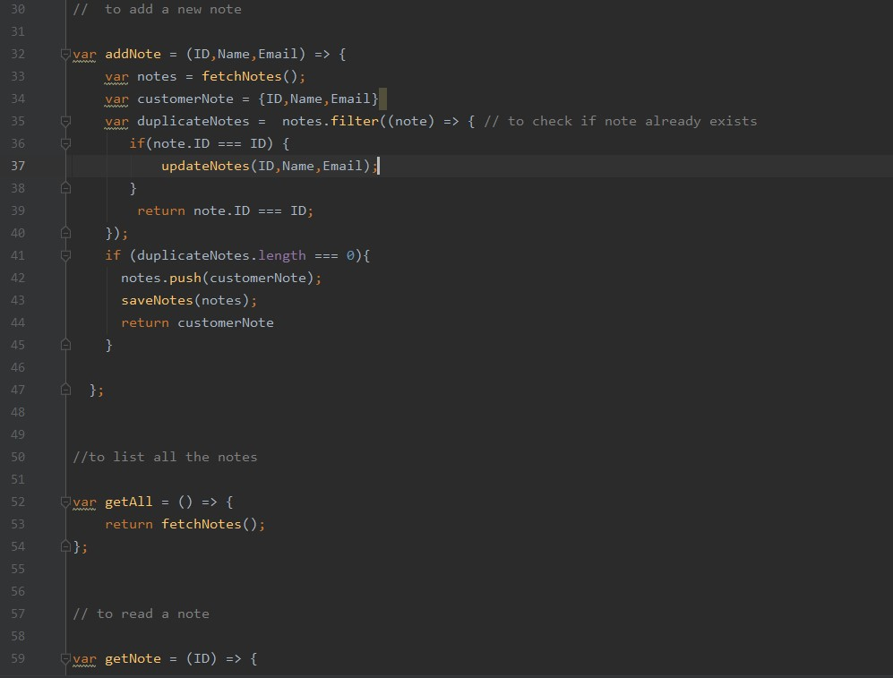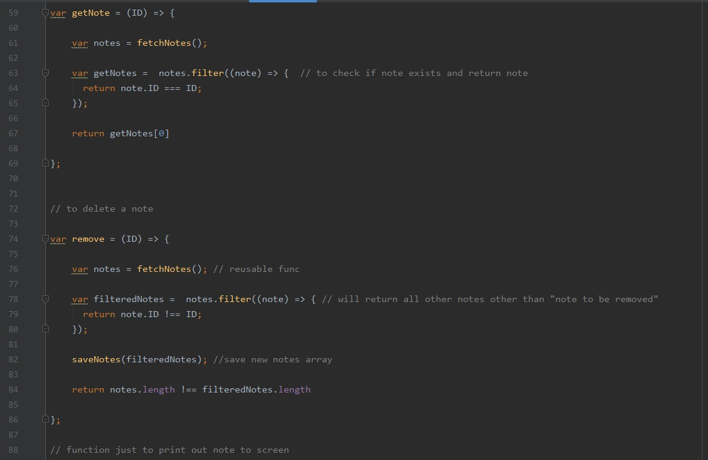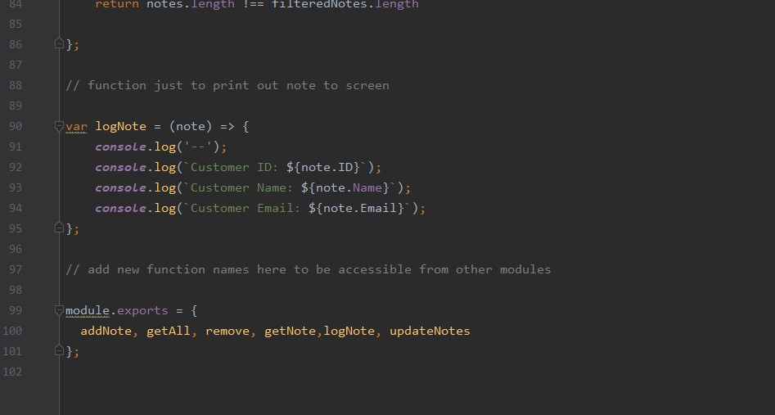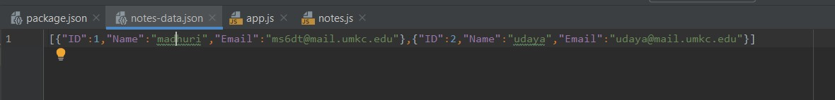

Output screens:

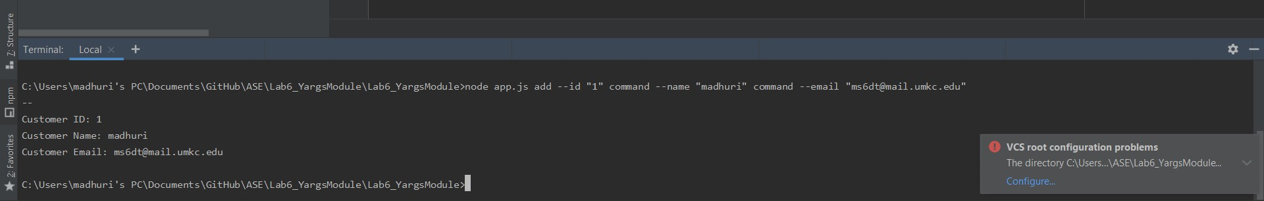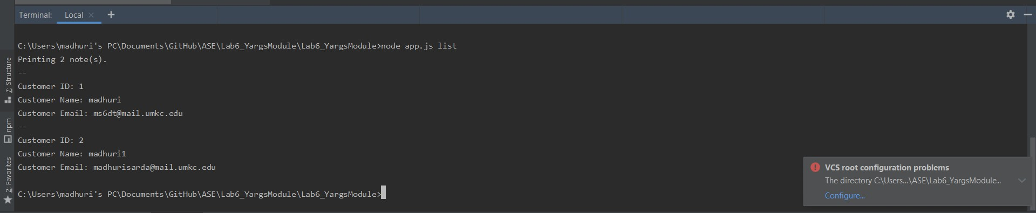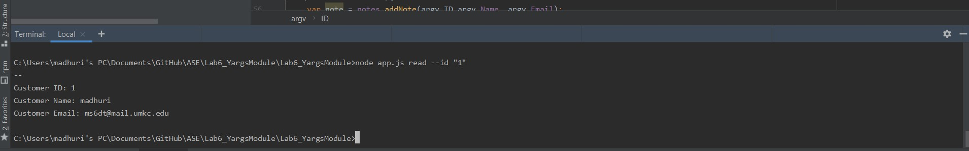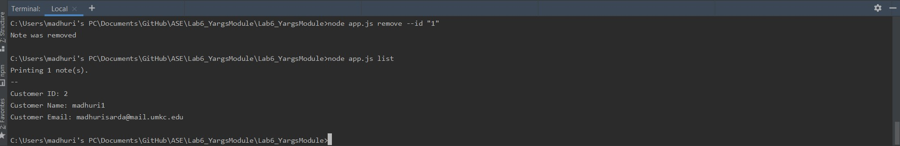

The link to the document with the code snippet is The link to the document with the code snippet is

<https://github.com/udayabyreddy/ASE/blob/master/Lab6_YargsModule/SourceCode_Lab6_CR UD_Operations_using_Yargs_Module.docx>